**SYSTEM ANALYSIS AND DESIGN**

**SECD2613-03**

Group: Tech Brothers

Members:

|  |  |
| --- | --- |
| HUWA JIA SHENG | A23CS5005 |
| ABDELRAHMAN OSAMA SAID ABDELMOBDY | A23CS4001 |
| AHMED KHALID AHMED MOHAMMEDAHMED | A23CS4037 |
| AMER FITRI BIN JIMMY | A23CS5041 |

Lecturer:

Ms. Rozilawati binti Dollah

**Topic:**

Campus Resource Management System

**Project Proposal:**

**1.0 INTRODUCTION**

The Campus Resource Management System (CRMS) is a pivotal advancement in the realm of educational administration. It is a comprehensive software platform designed to streamline various administrative and operational processes within a university or college campus. It's purpose is to serve as a centralized hub for managing and optimizing resources, facilities, events, students, faculty, and staff.

It's functionalities range from managing Facilities, Events, Students, Staff and even Communications. CRMS seamlessly integrates multiple functionalities into a unified framework, thereby simplifying resource allocation, scheduling, communication, and decision-making processes.

CRMS offer a multitude of benefits to educational institutions, ranging from enhanced operational efficiency to Efficient resource allocation by providing a centralized platform for managing campus resources, resulting in cost savings and increased productivity. Moreover, CRMS facilitate seamless communication and collaboration among stakeholders, fostering a cohesive campus community.

Overall, CRMS serve as transformative tools that not only modernize campus operations but also enrich the educational environment, ultimately supporting the institution's mission of academic excellence and student success.

**2.0 Background Study**

In recent years, Higher Education has been advancing further, marked by an exponential growth in student enrollment, an expanding array of academic programs, and an increasingly diverse set of campus stakeholders. Because of that, the management of campus resources has become much harder and difficult to maintain properly, needing innovative solutions to address the mthese problems

For Universities, the effective management of campus resources stands as a critical priority for educational institutions worldwide. Traditional approaches to resource management, characterized by fragmented systems and manual processes, have proven inadequate in meeting the evolving needs of modern campuses. In response to these challenges, Campus Resource Management Systems (CRMS) have emerged as transformative tools designed to streamline administrative processes, optimize resource allocation, and enhance stakeholder engagement within educational institutions.

At their core, CRMS serve as centralized platforms that integrate various functionalities to facilitate the efficient management of campus resources. These systems encompass a wide range of features, including facility booking and management, event planning, student and faculty management, communication and notification tools, and analytics capabilities. By consolidating these functions into a unified framework, CRMS empower administrators to make data-driven decisions, allocate resources effectively, and enhance the overall campus experience for students, faculty, staff, and administrators.

CRMS also play a crucial role in supporting strategic initiatives and institutional goals within educational institutions. By offering insights into campus operations and resource utilization through analytics and reporting features, CRMS enable administrators to identify areas for improvement, track performance metrics, and measure the impact of their initiatives. This data-driven approach to decision-making fosters a culture of continuous improvement and innovation, driving institutional excellence and student success.

In conclusion, this shows the urgent need for Educational Institutions to employ campus resource management systems like CRMS in the face of mounting demands and evolving educational paradigms. By leveraging the capabilities of CRMS, institutions can not only enhance operational efficiency but also foster a dynamic and collaborative environment conducive to academic excellence and student success.

**3.0 Problem Statement**

In the modern landscape of higher education, universities and colleges face a myriad of challenges in effectively managing their campus resources. The traditional methods of resource management, reliant on manual processes and fragmented systems, are no longer sufficient to meet the evolving needs of academic institutions. This inefficiency leads to underutilization of resources, scheduling conflicts, communication gaps, and ultimately impacts the overall quality of education and campus experience.

**Here are some Challenges in Campus Resource Management**

**1.Fragmented Systems:** Disparate systems and manual procedures for facility reservations, event planning, student enrolment, and faculty/staff administration characterize the current state of campus resource management. This fragmentation leads to data silos, duplication of work, and a restricted understanding of the overall use of resources**.**

**2. Inefficient Resource Utilization**: Ineffective Resource Use: Lack of understanding of the availability, demand, and usage trends of resources results in the underutilization of university facilities like labs, sports fields, halls, and classrooms. The institution's capacity to optimize its resources is hampered by this inefficiency, which also results in needless expenses.

**3. Communication Breakdowns:** Communication breakdowns: The difficulties of managing resources are made worse by a lack of communication amongst administrators, teachers, students, and departments. Ineffective communication channels frequently lead to irregular event planning, incongruous scheduling, and a disorganized resource allocation strategy.

**4**. **Manual Administrative Procedures**: Manual administrative procedures take a lot of time, are prone to mistakes, and can cause delays in processes like course registration, student registration, faculty scheduling, and performance reviews. This hinders the institution's overall operational efficiency in addition to taxing the administrative staff.

**5.** **Accessibility and Inclusivity:** It can be difficult to guarantee that everyone in the community, including those with disabilities, has equal access to campus resources. Proactive measures are necessary to address accessibility barriers in facilities, technologies, and services that may restrict the participation and engagement of specific groups.

**6. Financial Sustainability and Budgetary Restraints:** The institution's ability to invest in new infrastructure, technological advancements, or resource expansion may be compromised by a lack of funding. Campus administrators are constantly faced with the challenge of allocating resources to meet present needs while preserving long-term financial sustainability.

**7.** **Data Management:** Without strong data management systems in place, managing enormous volumes of data about resource usage, event scheduling, student enrolment, and faculty/staff information can be daunting. Effective decision-making requires integrating data from various sources and guaranteeing data consistency and accuracy.

8. **External Partnerships and Community Engagement**: External Partnerships and Community Engagement: It can be difficult to work together with outside partners to support campus initiatives and obtain more funding. Examples of these partners include regional businesses, governmental bodies, and community organizations. It takes skilful relationship management, negotiation, and communication to build and sustain successful partnerships.

**9. Environmental Impact and Sustainability:** It's getting more and more crucial to encourage sustainable practices and lessen the negative effects of campus operations, like energy use, waste production, and transportation. Nonetheless, the organization must commit resources and time to putting sustainable initiatives into action and evaluating their success.

In the end, in order to effectively manage campus resources and support the institution's mission, addressing these challenges calls for a multifaceted approach that incorporates technology solutions, process improvements, stakeholder engagement, and strategic planning.

**4.0 Proposed Solutions**

**These are some of the Proposed Solutions.**

**1.Integrated Campus Resource Management System:** Install a central Campus Resource Management System (CRMS) to handle all aspects of resource management, such as scheduling facilities, organizing events, and administering students, faculty, and staff. By using an integrated approach, all campus resources will be managed from a single platform, doing away with the need for manual processes and different systems.

**2.** **Resource Utilization Dashboard:** Provide administrators with information about how campus facilities are being used by creating a real-time resource utilization dashboard in the CRMS. Key metrics including facility occupancy rates, peak usage hours, and demand forecasts should be shown on this dashboard so that administrators can maximize resource allocation and pinpoint underutilized areas that could use improvement.

**3.** **Automated Scheduling and Allocation:** Incorporate automated scheduling algorithms into the CRMS to maximize campus resource distribution according to demand, availability, and priority. To guarantee effective facility utilization with no scheduling conflicts, these algorithms should consider variables like class schedules, event reservations, and maintenance needs.

**4.** **Administrative Procedures Simplified:** Automate and optimize workflow to streamline administrative tasks within the CRMS, such as staff and faculty management, course registration, and student enrolment. Administrative employees can focus on more strategic tasks, save time, and minimize errors by digitizing these processes and doing away with manual paperwork**.**

**5. Tools for Collaboration and Communication** Add collaboration and communication tools into the CRMS to enable smooth departmental, faculty, student, and administrative interactions. In order to guarantee prompt communication and coordination in resource management tasks, these tools could include feedback mechanisms, event notification alerts, and messaging systems.

**6.** **Instruction and Assistance for Users:** To guarantee the seamless adoption and use of the CRMS, give users thorough training and continuing assistance. Training courses, user guides, online tutorials, and special support channels to handle any.

7**. Techniques for Data Security and Privacy:** Incorporate strong data security and privacy protocols into the CRMS to safeguard confidential data and guarantee adherence to legal mandates like GDPR and HIPAA. To protect the integrity and privacy of campus data, this may entail data protection policies, access controls, encryption protocols, and routine security audits.

8.**Proactive Outreach:** Determine Possible Partners: Find neighbourhood companies, governmental institutions, and community groups that have resources that support campus initiatives or that have similar objectives by conducting research.

Make Contact: Reach out to potential partners through personalized emails, phone calls, or networking events to initiate conversations and express interest in collaboration, Cultivate Trust: Establish rapport and trust with outside partners by being dependable, consistent, and open in all of your communications.

Create Personal Connections: To promote cooperation and problem-solving, cultivate personal connections and relationships with important stakeholders within external partner organizations.

**9.** **Programs for Energy Conservation:**

Perform Energy Audits: Examine how much energy is being used in all campus buildings to find inefficiencies and potential areas for improvement.

Put Efficiency Measures into Practice: To maximize energy use, install energy-efficient heating, cooling, and lighting systems along with smart building technologies.

Encourage the use of conservation techniques: Urge students to embrace energy-saving practices by teaching them to shut off lights and appliances when not in use**.**

**Seek LEED Certification: New construction and renovation projects** should strive for LEED (Leadership in Energy and Environmental Design) certification in order to ensure sustainable building practices and environmental performance.

Renovate Current Structures: To meet green building requirements, retrofit existing structures with energy-efficient HVAC systems, improved insulation, and eco-friendly materials.

Highlight Green Elements: Use signage, tours, and promotional materials to showcase the building's green features and certifications as evidence of the institution's commitment to sustainability.

In the end, academic institutions can overcome the difficulties with campus resource management and build a more productive, sustainable, and welcoming campus community by putting these suggested solutions into practice. For each solution to be as effective as possible in resolving resource management issues, it can be customized to the unique requirements and institutional context.

**5.0 Objectives**

**Aligned with the proposed solutions, the objectives of the project are as follows:**

1. Enhance resource utilization: Improve the utilization of campus facilities and resources to maximize efficiency and reduce unnecessary expenses.
2. Streamline administrative processes: Automate administrative tasks to reduce errors, save time, and optimize staff productivity.
3. Foster communication and collaboration: Facilitate seamless communication and collaboration among stakeholders to enhance coordination in resource management activities.
4. Ensure accessibility and inclusivity: Implement measures to ensure equal access to campus resources for all members of the community, including those with disabilities.
5. Ensure data security and compliance: Establish robust data security protocols to protect confidential information and ensure compliance with legal regulations such as GDPR and HIPAA.
6. Foster external partnerships: Cultivate partnerships with external organizations to support campus initiatives and obtain additional resources.
7. Promote environmental sustainability: Implement energy conservation measures and sustainable practices to reduce the environmental impact of campus operations.

**6.0 Scope of the project**

**The scope of the project encompasses a comprehensive range of activities and initiatives aimed at implementing the proposed solutions and achieving the defined objectives. These include:**

1. Implementation of the CRMS: This involves the installation and customization of the Campus Resource Management System to address the specific needs and requirements of the institution. It includes configuring the system to handle various aspects of resource management such as facility scheduling, event organization, and student/staff administration.
2. Development of Resource Utilization Dashboard: Designing and implementing a real-time resource utilization dashboard within the CRMS to provide administrators with key metrics and insights regarding the usage of campus facilities. This includes monitoring facility occupancy rates, peak usage hours, and demand forecasts to optimize resource allocation.
3. Integration of Automated Scheduling Algorithms: Incorporating automated scheduling algorithms into the CRMS to optimize the distribution of campus resources based on demand, availability, and priority. This includes considering variables such as class schedules, event reservations, and maintenance needs to minimize scheduling conflicts.
4. Streamlining Administrative Processes: Automation and optimization of administrative tasks within the CRMS to streamline processes such as staff and faculty management, course registration, and student enrollment. This aims to reduce errors, save time, and improve overall operational efficiency.
5. Integration of Collaboration and Communication Tools: Adding collaboration and communication tools into the CRMS to facilitate smooth interactions among departments, faculty, students, and administrative staff. This includes features such as feedback mechanisms, event notification alerts, and messaging systems to enhance coordination in resource management tasks.
6. User Training and Support: Providing comprehensive training programs, user guides, online tutorials, and support channels to ensure the seamless adoption and utilization of the CRMS by all stakeholders. This includes ongoing assistance to address any user queries or issues that may arise during the implementation process.
7. Implementation of Data Security Measures: Incorporating robust data security and privacy protocols into the CRMS to safeguard confidential information and ensure compliance with legal regulations such as GDPR and HIPAA. This includes the implementation of data protection policies, access controls, encryption protocols, and routine security audits.
8. Proactive Outreach for Partnerships: Conducting research to identify potential partners from neighborhood companies, governmental institutions, and community groups that can support campus initiatives or share similar objectives. This involves reaching out to these partners through personalized communications, networking events, and establishing personal connections to cultivate trust and collaboration.
9. Initiatives for Environmental Sustainability: Conducting energy audits to assess the energy usage in campus buildings and identify inefficiencies for improvement. Implementing energy conservation measures, sustainable practices, and seeking LEED certification for new construction and renovation projects to reduce the environmental impact of campus operations.

By defining the scope of the project to include these key activities and initiatives, the institution can effectively address the challenges in campus resource management and achieve the objectives outlined in the proposal.

**7.0 Project Planning**

**7.1 Human Resource**

To successfully develop and deploy the Faculty and Staff Management module, the project team consists of:

**7.2 Work Breakdown Structure (WBS)**

**7.3 PERT Chart (Based on WBS)**

|  |  |  |  |
| --- | --- | --- | --- |
| No | Activity | Predecessor | Duration  (Weeks) |
| 1 | Project Planning | None | 2 |
| 2 | Requirement Analysis | 100 | 2 |
| 3 | System Design | 100 | 2 |
| 4 | System Development | 200,300 | 2 |
| 5 | Testing and Quality Assurance | 400 | 2 |
| 6 | Deployment | 500 | 2 |
| 7 | Employee Training | 600 | 1 |
| 8 | System Documentation | 700 | 1 |

A

**100,2 200,2 400,2 500,2 600,2 700,2 800,2**

B

H

G

F

E

D

C

**300,2**

D

**Critical Path:**

100-200-400-500-600-700-800

Total length = 12

100-300-400-500-600-700-800

Total length = 12

**7.4 Gantt Chart**

Faculty and Staff Management

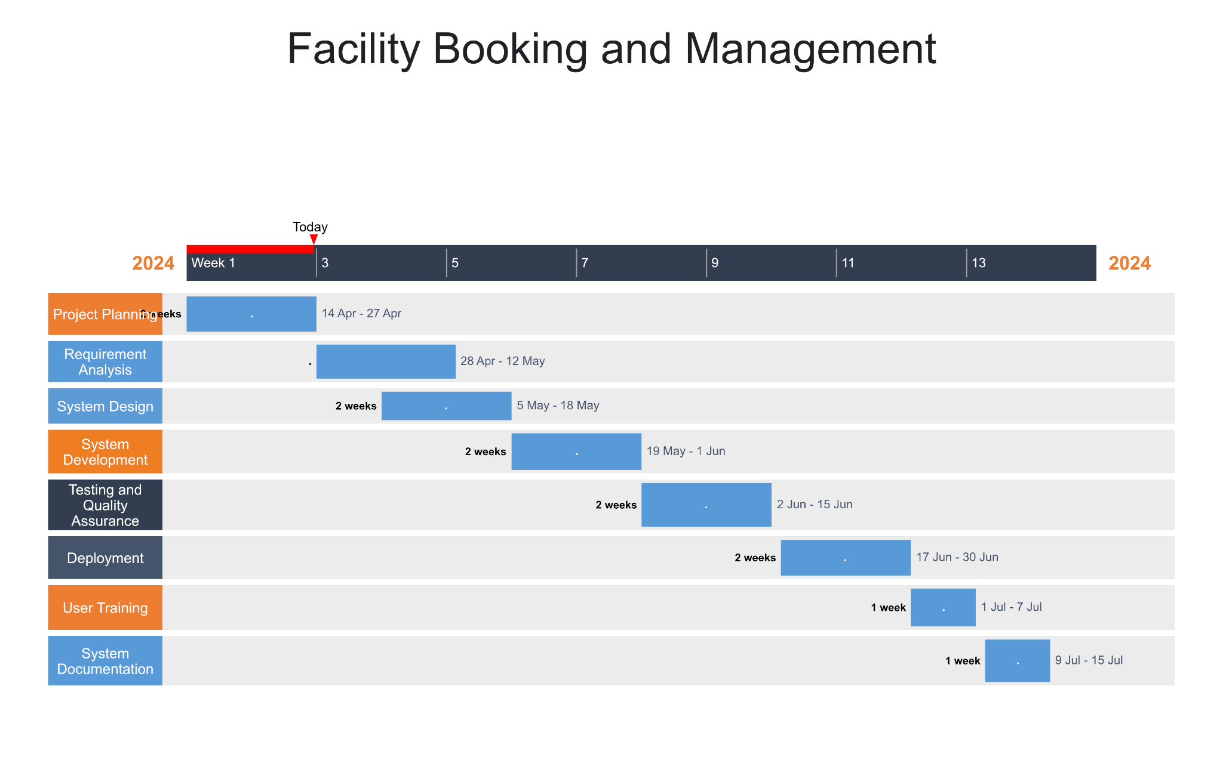

**8.0 Benefit and Overall Summary of Proposed Solution**

**In brief:**

For educational institutions facing difficulties in effectively managing their resources, the Campus Resource Management System (CRMS) provides a comprehensive answer. It combines different administrative tasks, improves channels of communication, and distributes resources as efficiently as possible among departments and stakeholders.

CRMS reduces human labor and gets rid of disjointed systems by streamlining administrative procedures. As for the result, operational effectiveness is increased and employees are free to concentrate on key projects rather than tedious duties. Additionally, CRMS promotes an integrated campus environment by facilitating smooth communication and collaboration between departments, faculty, students, and administrators.

CRMS also makes the most of campus resources by providing real-time insights into demand and use of resources. This helps to reduce wasteful spending and guarantees fair access for all community members. In addition, strong data security procedures protect private data and ensure compliance with legal regulations, for promoting trust and integrity.

Through proactive outreach, CRMS cultivates connections with other organizations, strengthening campus efforts and acquiring supplementary resources for enduring expansion. Additionally, by putting energy-saving measures and sustainable practices into practice, the system encourages environmental sustainability and helps create a greener campus community.

In general, CRMS is a revolutionary tool that advances sustainability, encourages teamwork, and modernizes campus operations—all of which strengthen the institution's core values of academic achievement and student success.

**8.1 Github**

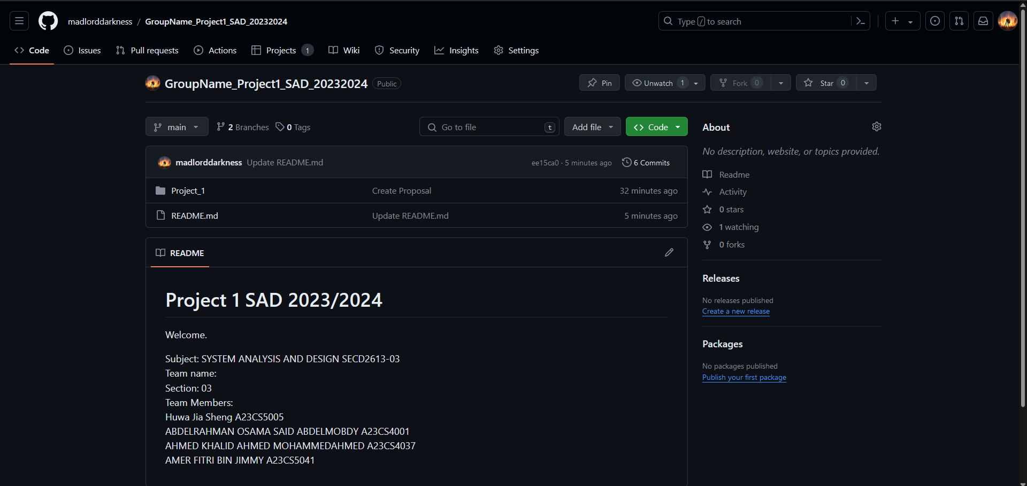

Link: https://github.com/madlorddarkness/GroupName_Project1_SAD_20232024